Project Design Phase-II
Data Flow Diagram & User Stories

Date | 31 January 2026
Team ID | LTVIP2026TMIDS84622
Project Name | FlightFinder – Navigating Your Air Travel Options
Maximum Marks | 4 Marks

Data Flow Diagrams:
FlightFinder – Navigating Your Air Travel Options connects travelers, airlines, and technology to deliver a fast, convenient, and reliable flight booking experience. The platform gathers data from users, airlines, and integrated services—processes it—and provides real-time flight availability, secure booking management, and instant confirmation updates. Simple, efficient, and user-centric.
○ User interactions are handled through an intuitive web interface for searching flights, comparing prices, selecting seats, and completing bookings.
○ Real-time data from airlines, flight schedules, seat availability, and payment gateways is collected and processed securely.
○ Booking status and flight details are monitored and updated instantly to ensure accurate information.
○ Payment transactions are processed securely through third-party payment gateway integrations.
○ Booking history, user insights, and flight management data are generated for travelers and administrators to improve decision-making and service efficiency.
Example: DFD Level 0 (Industry Standard)
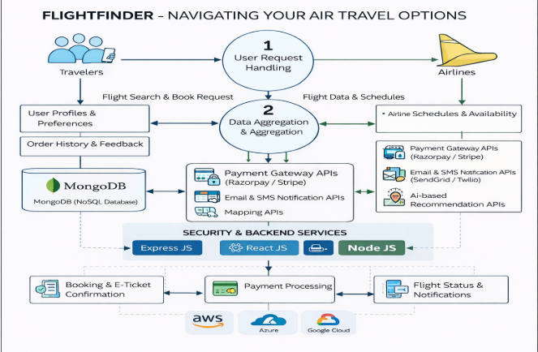

User Stories
Use the below template to list all the user stories for the product.
User Type | Functional Requirement (Epic) | User Story Number | User Story / Task | Acceptance criteria | Priority | Release
Customer (Mobile user) | Registration | USN-1 | As a user, I can register for the application by entering my email, password, and confirming my password. | I can access my account / dashboard | High | Sprint-1
 |  | USN-2 | As a user, I will receive confirmation email once I have registered for the application | I can receive confirmation email & click confirm | High | Sprint-1
 |  | USN-3 | As a user, I can register for the application through Google login. | I can register & access the dashboard with Google Login | Medium | Sprint-1
 | Login | USN-4 | As a user, I can log in using email and password. | I can access my account successfully. | High | Sprint-1
 |  | USN-5 | As a user, I can reset my password if I forget it. | I receive reset link and can create new password. | High | Sprint-1
 | Flight Search | USN-6 | As a user, I can search flights by source, destination, and date. | System displays available flights. | High | Sprint-1
 |  | USN-7 | As a user, I can filter flights by price and airline. | Filtered results are  displayed correctly. | Medium | Sprint-2
 | Flight Booking | USN-8 | As a user, I can select a flight and enter passenger details. | Passenger details are saved before payment. | High | Sprint-1
 |  | USN-9 | As a user, I can make secure online payment. | Payment is processed securely and confirmed. | High | Sprint-1
 |  | USN-10 | As a user, I receive booking confirmation and e-ticket. | Confirmation email and ticket are generated. | High | Sprint-1
 | Booking Management | USN-11 | As a user, I can view my booking history. | Past and upcoming bookings are visible. | Medium | Sprint-2
 |  | USN-12 | As a user, I can cancel a booking. | Booking status updates after cancellation. | Medium | Sprint-2
Customer (Web User) | Flight Search | USN-13 | As a web user, I can search and compare flights. | Search results are displayed clearly. | High | Sprint-1
 | Booking | USN-14 | As a web user, I can book a flight online. | Booking is successfully confirmed. | High | Sprint-1
Administrator | Flight Management | USN-15 | As an admin, I can add new flights. | Flight is added to system database. | High | Sprint-1
 |  | USN-16 | As an admin, I can update flight details. | Updated details are reflected in search results. | High | Sprint-1
 |  | USN-17 | As an admin, I can delete flights. | Flight is removed from system. | Medium | Sprint-2
 | Booking Management | USN-18 | As an admin, I can view all bookings. | All booking details are displayed. | High | Sprint-1
 | Reports | USN-19 | As an admin, I can generate booking reports. | Report is generated successfully. | Medium | Sprint-2

